Development Database

Solution Design Document

|  |  |  |  |
| --- | --- | --- | --- |
| **Document filename:** | Development Database  Solution Design Document(SDD) | | |
| **Issue date:** | 06-March-2016 | | |
| **Update date** | 18-April-2017 |  |  |
| **Version:** | 1 |  |  |
|  |  | | |

# Approval

|  |  |  |
| --- | --- | --- |
| **Approver** | **Approved** | **Approval Date** |
| **Project Manager:** |  |  |
| **Project Sponsor:** |  |  |
| **Lead BA:** |  |  |
| **Technical Lead:** |  |  |
| **Solutions Lead:** |  |  |
|  |  |  |

# Document History

|  |  |  |  |
| --- | --- | --- | --- |
| Version | Responsible | Date | Notes |
| Version 1.0 | Minh | 06-March-2016 | Initial Solution Design Database |
| *** End of Revision List *** | | | |

Table of Contents

Approval 2

Document History 3

1 Introduction 4

1.1 Background 4

1.2 Document Purpose 4

1.3 Scope 4

1.3.1 In scope 4

1.3.2 Data Integration Scope 4

1.3.3 Not in scope 4

1.4 Definitions, acronyms and abbreviations 5

1.5 References 6

1.6 Issues and Assumptions 7

2 SSD Account Management 8

2.1 Account Management Map 8

2.2 Access Permissions 8

2.2.1 Overview 8

2.2.2 Table of Claims and Screens 8

2.3 Account Mangement 8

3 . Development Process data in Database 14

3.1. Overview 14

3.2. Store Procedure 14

3.3. Process flow 14

4 Architecture 15

4.1 Overview 15

4.1.1 Metadata Architecture 15

Appendix A – Implementation Strategy 16

# Introduction

## Background

This document will initial concept and convention for the requirements to design solution Database BSportTeamDB. The BSportTeamDB is the central Database for developing application web.

* BSportTeam for Booking Team football

The SSD will has the capability to analyse and clarify clearly requirements development Database adapt as solution design central database for application web.

In SSD, I only record solution design to be updated until present. For development in future, this document will be updated to the latest solution .

## Document Purpose

This document will identify the requirements specific to in scope follow version development Database BSportTeamDB.

## Scope

### In scope

Listed below are the changes required to external systems considered part of this development

### Data Integration Scope

Design and development on Database tier only cover management’s account platform

* Registration account and simply manipulate on account (insert, update, create)
* Security account about role and privilege in application
* Finding player for booking team

**Sprint 1: Scope**

* Manage account platform
* Security account role , account privilege
* List table administration
* Develop process Booking team ‘sport

Finding player

Stadium

Time

### Not in scope

This document will not cover any of the next stage of project

## Definitions, acronyms and abbreviations

|  |  |
| --- | --- |
| Term | Definition |
| BSportTeamDB | BSportTeam Database |
| SDD | Solution Design Database |
|  |  |
|  |  |

## References

| Document | Location |
| --- | --- |
|  |  |

## Issues and Assumptions

|  |  |
| --- | --- |
| Item | Description |
|  |  |
|  |  |

# SSD Account Management

## Account Management Map

## Access Permissions

### Overview

The application will implement a claims based security model of access permissions. Unless the User has the correct claim they will not have permission to do something.

### Table of Claims and Screens

|  |  |
| --- | --- |
| Claim | function |
| CanExecuteUserManagement | Management on owner account |
| Administrator Role | User Management |

## Account Mangement

**Diagram:**

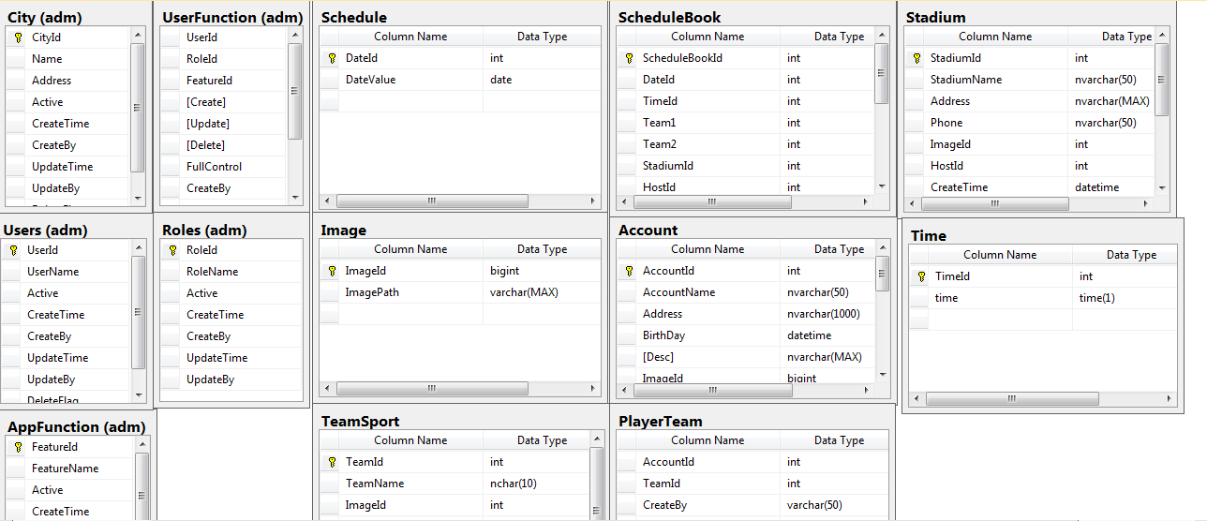

2.3.1. adm.Roles

This table will be defined whole roles in website

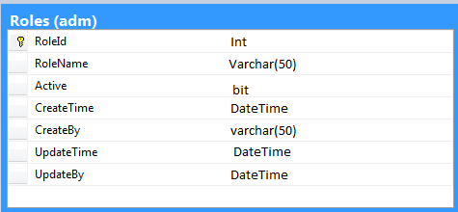

2.3.2.adm.Users

This table will be contained all Users in group management and manipulation function on website

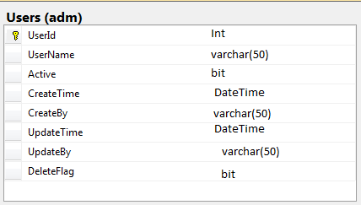

2.3.3. adm.AppFuction

This table will be defined whole function this website provision

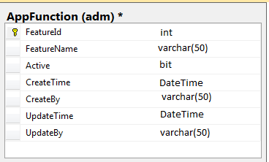

2.3.4. adm.UserFunction

This table contains all privilege on features following role of website

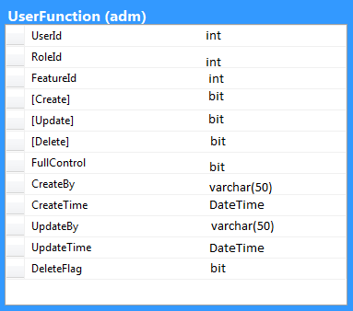

2.3.5. mst.City

This table contains detail city which website supports

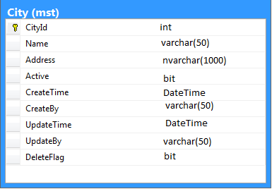

2.3.6. dbo.Account

This table contains all account that sign up

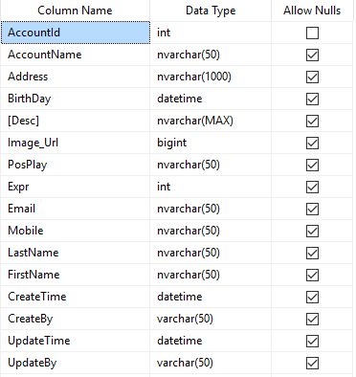

2.3.7.dbo.TeamSport

This table contains all TeamSport in Website

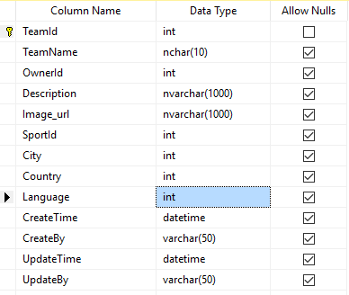

2.3.8.dbo.PlayerTeam

This table contains the relationship between Player and TeamSport and Roles of this account in team

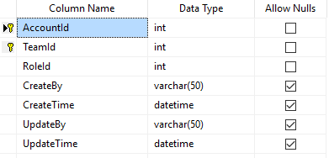

2.3.9. dbo.Roles

This table contains the role of account in team is host or member

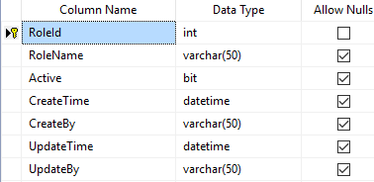

2.3.10. dbo.Account_teamplayer

This table contains the connection between account and team



2.3.11. dbo. Queue

This table contains request from host of team to account to invite them to become member of team.

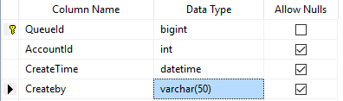

2.3.12.dbo.ScheduleBook

This table contains detail information of the match will be taken place

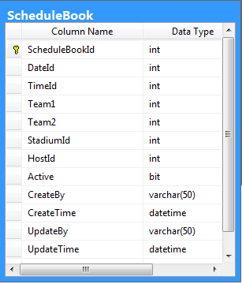

2.3.13.dbo.Post

This table contains posts from account in specific team to share moment in football match

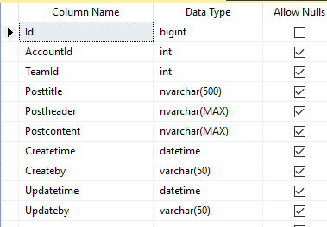

2.3.9. mst.Schedule

This table contains schedule the match of teams on date

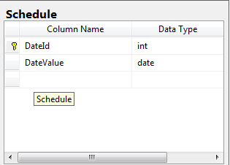

2.3.10.mst.Time

This table contains the time is booked by account and confirmed from host

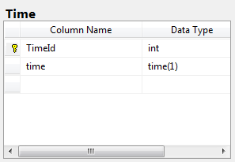

2.3.12. mst.Stadium

This table contains Stadium which the match will be taken place

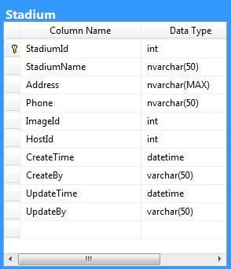

2.3.13. dbo.Image

This table is stored Image for website ( Stadium, account etc.)

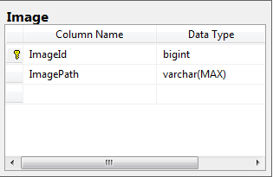

# . Development Process data in Database

### 3.1. Overview

The purpose of work piece is to record all object for processing data tier example Store Procedure, Trigger, Function etc. Explanation detail what object will be used for in Database?

### 3.2. Store Procedure

- CreateAccount : this store procedure to support creation account in DB

- uspLogError : This SP to Write log if Processing in DB is errored

- uspPrintError : this SP to Print Message Error

### 3.3. Process flow

# Architecture

## Overview

The development Structure Database will use the metadata tool to build structure object in DB .

### Metadata Architecture

# Appendix A – Implementation Strategy

**Deployment Servers**

**Local**

-TBC-

**Local.\PROD**

-TBC-

**TFS**

-TBC-

**Tuan environment**